Oslo, 15.11.2023
For immediate release:
Formula for change: UECC solution for EU ETS gives clients clarity on emission costs
Cargo owners seeking to determine their Scope 3 emission liabilities from the logistics chain must contend with multiple calculation methods from different shipping lines that will affect their costs exposure to the EU ETS for shipping. To resolve this conundrum for its clients, Pure Car and Truck Carrier (PCTC) owner and operator UECC has adopted a standardised methodology based on an existing and trusted industry framework.
The EU Emissions Trading System (EU ETS), set to be phased in for shipping from 1 January 2024, will require shipping companies calling at European ports to purchase so-called EU Allowances (EUAs), or carbon credits, corresponding to each tonne of CO2 emitted to cover their annual emissions.
This is effectively a tax on the use of fossil fuels in line with the price of EUAs, currently at around €80, with these costs to be distributed across the value chain based on the ‘polluter pays’ principle that underpins the regulation.
This entails establishing a mechanism for allocation of these additional fuel costs to various stakeholders, including the cargo owner, that can be used to fairly and accurately calculate EUA liabilities based on their respective share of emissions.
The price is right?
“Having to relate to shipping lines’ possible different formulas for calculation of emissions costs both increases the administrative burden and creates confusion for cargo owners. This can also result in higher costs for clients due to overcharging and, consequently, inequitable distribution of EUA liabilities across the value chain,” according to UECC’s Energy & Sustainability Manager Daniel Gent.
This could, for example, lead to a “ridiculous situation” where a cargo owner receives a Scope 3 footprint of 2000mts of CO2 emissions based on transport work undertaken, but is asked to pay for the equivalent of 3,000mts of CO2 as the EU ETS cost is calculated based on other external factors, such as higher T/C rates, bunker prices, etc. “A cargo owner has every right to expect to pay for the emissions generated as a result of its cargo shipment, not more and not less,” Gent says.
UECC, a leading sustainable Ro-Ro carrier operating in the European shortsea trade, has therefore adopted its calculation formula based on the existing methodology for GHG emission accounting developed by the Association of European Vehicle Logistics (ECG) and Smart Freight Centre, together with UECC and other stakeholders, and incorporating ISO standards.
Need for uniform EU ETS formula
The so-called ‘Ro-Ro GHG Emissions Accounting Guidance’ sets the standard for reporting of shipment emissions, transport activity and carbon intensities from multi-modal transport operators to cargo owners and is intended to create a harmonised and transparent methodology for calculation and reporting of logistics GHG emissions for the Ro-Ro industry.
This is consistent with existing industry and international standards regarding carbon accounting for the logistics industry, namely the GLEC Framework and ISO 140832. The GLEC Framework is in turn aligned with the principles of the IMO’s Energy Efficiency Operation Index.
Gent says this regime is already widely used by cargo owners to determine their Scope 3 emissions from transport and logistics for the purposes of ESG reporting and it is therefore logical that this should form the basis for UECC’s EU ETS calculation method.
“Our EU ETS solution is intended to provide clarity, transparency and predictability for clients so they can gain a correct picture of their emission costs, based on an equitable calculation of pricing that correlates to their actual carbon footprint. We believe this is a credible method that could form the basis for a uniform EU ETS formula that would be very much welcomed by the industry,” Gent says.
Maximising cargo to cut carbon intensity
“At the same time, this eliminates a lot of administrative legwork for clients as it gives them a reliable, pre-calculated price determined according to verified emissions data recorded for the UECC fleet and already accounted under the established regime.”
The UECC formula calculates EUA costs for the cargo owner using its fleet average carbon intensity, or the average amount of CO2 emitted per CEUkm, which is the relative size of the cargo in Cargo Equivalent Units (CEUs) and the distance it is being transported.
Carbon intensity is multiplied by CEU volume and an adjusted figure for shortest feasible distance between port of loading and port of discharge to determine tonnes of CO2 emitted. This is then multiplied by the average EUA auction clearing price on the European Energy Exchange in a given reference period to give the final cost for the client.
UECC’s Senior Manager Business Planning & Sustainability, Masanori Nagashima, says a key factor in lowering the carbon intensity of shipments - and therefore EU ETS cost liabilities for cargo owners - is high utilisation of vessels to maximise cargo volumes per shipment, as well as customer support for green technologies to power ships. “This requires all industry stakeholders to work together and pull in the same direction towards decarbonisation of shipping,” he says.
Getting bang for green buck
Gent says cargo owners are increasingly focused on gaining the biggest carbon reduction for their money when buying shipping services to meet their ESG targets. Having a market-based mechanism for carbon pricing in place with the EU ETS for shipping will effectively make green carriers more attractive than those using more pollutive fuels, he explains.
“Investing in green technologies and alternative fuels to lower the carbon footprint of vessels will contribute to reduced costs exposure for clients under the EU ETS, making it cheaper for them to reach their sustainability goals,” Gent says.
UECC has a roadmap in place to reduce the carbon intensity of its fleet, having already made prescient investments in green newbuilds - a pair of the world’s first dual-fuel LNG PCTCs followed by three innovative multi-fuel LNG battery hybrid PCTCs - that are able to cut emissions by around 25% by using liquefied natural gas (LNG).
These vessels are also equipped to run on drop-in fuels with lower carbon intensity such as bio-LNG and synthetic LNG as these become more widely available. In addition, UECC has piloted the use of carbon-neutral biofuels on other vessels in partnership with clients such as BMW, giving a wide range of options for customers to continuously reduce their carbon footprint.
“The EU ETS is a cap-and-trade system designed to incentivise the use of low-carbon technologies by making the use of conventional fossil fuels relatively more expensive. And UECC is putting this principle into action,” Gent concludes.
For more information contact:
Bjorn O. Gran Svenningsen, Director Sales & Marketing, UECC
Email: bsv@uecc.com

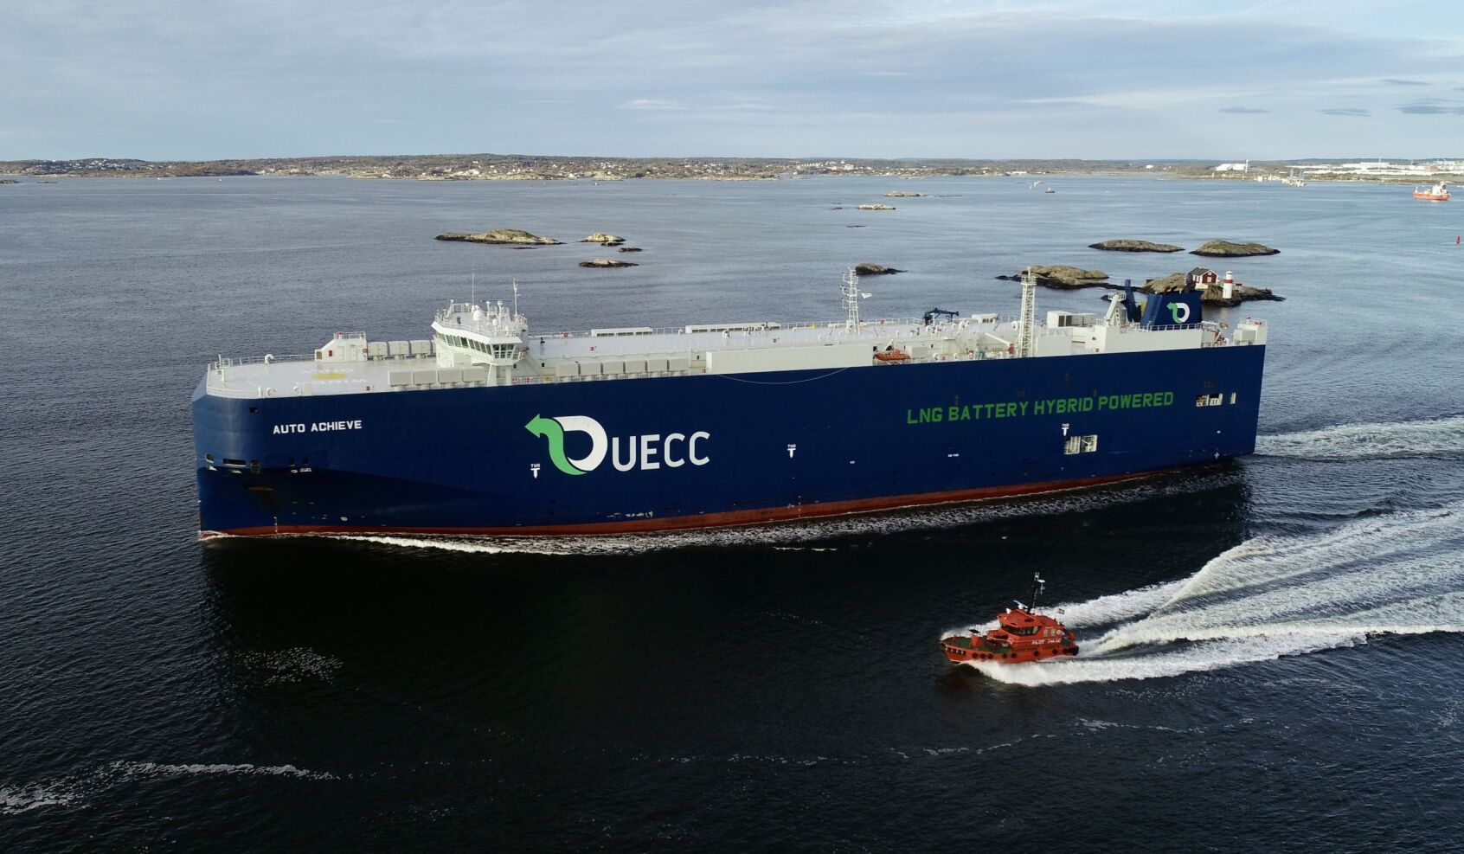
UECC’s multi-fuel LNG battery hybrid PCTC, Auto Achieve
Photo: Tomas Østberg-Jacobsen

